Facing the Global Family Challenge…with Hope
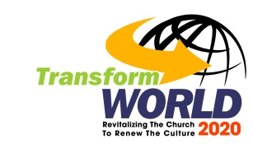

- Facing The Challenge
- The Unfolding Crisis
The global church watches, with great alarm, the escalating destruction of families in their midst, manifesting in various forms, including the divorce pandemic, the exodus of Christians from their faith in God, the failure of Christian parents in evangelizing the following generations, attempts to redefine marriage, etc.
The Church becomes dysfunctional as members of Christian families struggle with strained relationships. The breakdown of a marriage, the most intimate of all human relationships, mars the display of the agape kind of love between God and His Body, the Church and to the world. It incapacitates the family from passing on the faith from generation to generation. It affects our future, the church and the society.
In short, Satan is destroying the church by ruthlessly attacking Christian families.
How much longer can the church, presently faced with unabated family breakups of pandemic proportion, continue to effectively carry on as salt and the light to the world?
The family crisis is really the church crisis!
- Church’s Response
Though gallantly trying over recent decades to find ways to stem the tide of family meltdowns in our midst, results are far from satisfactory for the church. Worldwide family life statistics clearly point to satanic forces rapidly gaining ground in tearing apart the Christian family, the fibre from which all godly human institutions are woven.
Apart from attempts by the church during the Reformation and the brief period after that to give the family emphasis a healthy lift, biblical family-building has generally been off the main radar screen of the church. We are just not familiar (and are thus uncomfortable) with this part of church life.
A common tendency of the church, in response to a family life struggle, is to conduct a programme to try to ‘fix it’. This approach is typically ad hoc, stand-alone, and often inadequate. In the context of the family dynamic, a problem that surfaces in one area of the family could be intricately linked to other hidden areas of it.
We just cannot fix a profusely-bleeding wound with a small plaster.
What we need is a holistic strategy that takes into consideration all the key elements (e.g. marriage, parenting, faith formation, human sexuality, care for the aged, non-nuclear family living) needed to build the capacity of the family to fulfill its redemptive purpose in a church environment with healthy family-building as an integral part of its culture.
- Looking To God
- God’s Blueprint
The seriousness of the situation with the church not being in a position to build strong and healthy families becomes clear only when we recognise that the family is the primary institution that God has put in place to evangelising the next generation.
If the church is not doing much to equip the family to carry out this vital task, it faces the great risk of decline, as has been experienced by the Western churches when they failed over the years in building the families to raise the following generations in their faith in God. This is the Judges 2:10 scenario.
The Family: God’s plan for passing on the faith from one generation to another is primarily via the family. He is very specific in His instructions on how this is to be done. The Scriptures found in Deuteronomy 6:4-9, 11:13-21, Ephesians 6:4 clearly show this. God gives the family the jurisdiction over this key aspect (faith formation of children) of church life.
Families do not automatically become effective in faith formation of the next generation. Each family must be intentionally and systematically equipped to carry out this task. Their capacity for such equipping is affected by the state of marital relationships, parent-child relationships, human sexuality, care for the aged, family resource management, and so on. These are areas that the family needs to grow in in order to do the assigned task.
The Church: The global church, for various reasons, has generally assumed the primary responsibility of faith formation of the children in the last few centuries. This unbiblical, out-of-jurisdiction corporate task clearly has not produced the kind of faith needed for the next generation.
The biblical role of the church should be that of the ‘Family Equipping Centre’; equipping the family members ‘for works of service (Ephesians 4:11-13).
- The Ancient Path
In the midst of tumultuous struggles in our attempts to deal with the global family crisis, we believe God is calling us to return to the ancient path, asking ‘where the good way is, and walk in it’ (Jeremiah 6:16) in raising healthy families for Him in the last days.
The strategic focus is to build families according to God’s design, equipping them to be agents of change, and thereby impacting their communities for Christ.
This ‘Ancient Path’ we are to take is one that involves major culture shifts in the church and in the home, the two institutions that God established in advancing His Kingdom on earth.
- Stepping Forward
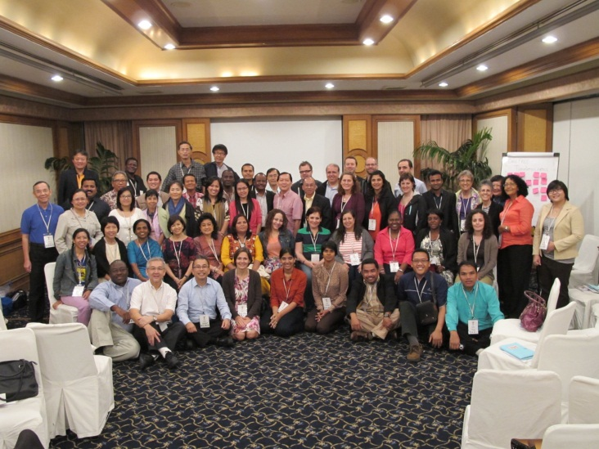
- The Pathway
Family Track, 4/14 Window Global Summit, October 2013
We do not lack family-building expertise, programmes, and resources needed for achieving our dream. In the last few decades God has raised up many gifted experts and organisations with useful resources for this purpose.
What we really lack is:
- commitment of the key stakeholders (the church and the home) to take up the family challenge, and
- an effective process that helps to make the culture shifts in these two institutions.
It takes a well-planned process to lead the church and the home from where they are to the kind of corporate church and home life that we are aiming for.
It requires the church to make a major paradigm shift on what constitutes effective family ministry (returning to the biblical pattern of family living) and to invest substantially more in manpower and resources to equip families than it currently is doing. In brief, a significant cultural shift in how the church ministers to the family.
Likewise, a major culture shift is needed in the ways the family is equipped for ministry at home.
Therefore, a well-planned process to lead the church and the home through culture shifts is critical to what we endeavor to accomplish.
This process of transforming the church to develop the biblical family involves implementing strategies in three phases.
- Preparing for the cultural shifts at the leadership, the congregational, and the home levels.
- Making the cultural shifts.
- Establishing the church and home cultures for the long-run.
- Family Culture Shift
The plumb line of healthy family living is indeed a big challenge for many families to measure up to.
Changing family culture is one of the toughest tasks we will face in this journey. The process requires reprioritization of family goals, reallocation of family resources, dealing with family struggles, etc. It is resource-consuming and depends on each family’s unique capacity for change.
Particular attention is needed on preparing a family properly for change through teachings and assurance of proper support infrastructures. Experience tells us that a lot of persuasion goes into motivating married couples to build better marriages, into parents to equip themselves better for their parental role, and for stakeholders to invest into systematic development of children holistically.
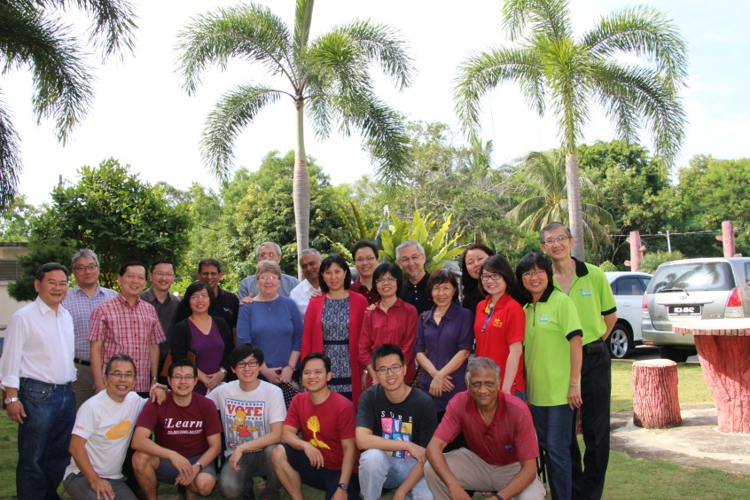
A strong leadership is also essential to lead families through the process. This can come from the adults in the families and the church; however initial leadership should come from the latter.
Family Ministries Consultation. May, 2014
- Church Culture Shift
In God’s design, families are not meant to take this journey of culture shift by themselves. God has given the church a mandate to support families in fulfilling their God-assigned purposes.
Though many Christian leaders give mental assent to the importance of Christian families in the redemptive plan of God, they often lack resolve to support these families on the practical level.
Developing healthy families requires the church to invest substantially more in manpower and resources than it is currently doing. To ensure healthy marriages requires the allocation of the right persons in the church to carry out the necessary tasks and the allocation of sufficient resources for personal coaching and the running of these programs on a long-term basis.
Churches are generally unprepared (and often unwilling) to climb this mountain of changes until they can resolve some key issues.
There are three main issues that clearly stand out consistently as we promote the healthy family emphasis to churches.
- Theological debate on the proper place (purpose and role) of the families in the church. The church leadership wants to know what God is saying in this area of the church life. For us, it was a surprise that many church leaders did not have a good grasp on the theology of family (including the theology of marriage and parenting).
- Accurate knowledge of the family health in the church. Many church leaders lack a clear picture of the state of health of the families in their midst. Many families are struggling under the weight of satanic attacks unknown to the leadership.
- Commitment of the church leadership to allocate resources commensurate with the family life needs. Often the pursuits of other corporate goals, such as church attendance, overshadow the family emphasis. This obstacle is usually overcome when the family breakdowns become too overwhelming for the church to ignore further.
- Strategic Leadership and Partnerships
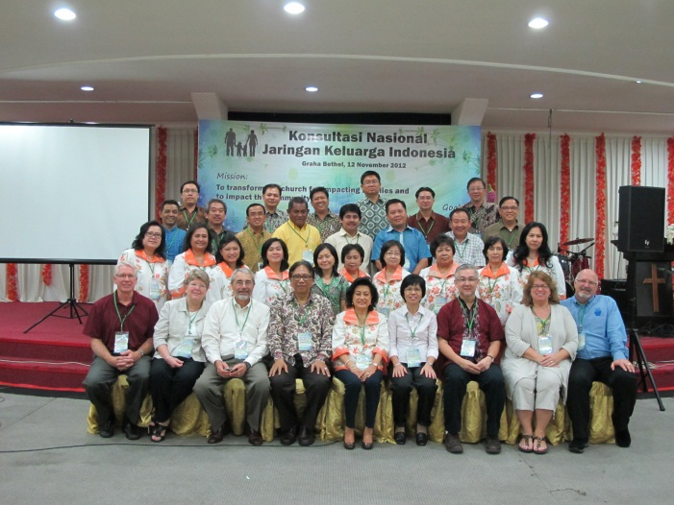
To be successful, we believe that the church must take the lead in deciding what needs to be done in building healthy families in their midst and partner with the home and the family ministry providers (such as family ministry individuals and organisations, e.g. Focus On The Family, FamilyLife, and Alpha) in a process that leads to the desired end.
Family Ministry Consultation, Jakarta
In the partnership between the church and the home, the emphasis should be on the latter as the primary place of faith formation.
There is also a great need to forge a much closer partnership between the church and family ministry providers in order to maximise the use of the kingdom resources for building healthy families.
- The Family Challenge Movement
- Our Response
Setting its sight on the transformation of communities around the globe, the Transform World Connections movement recognises the urgent need to restore the Christian family in the global church, under the auspice of Family Challenge, to their rightful place where they not only live a godly life (including passing on the faith to the following generations), but also have the capacity to heed the call to be the transformational agent that could significantly impact communities around the globe for Christ.
The task ahead for the Family Challenge is indeed immense. There are no quick-fixes for the broken family cistern.
However, we strongly believe that the time to respond to this call of God for the church body worldwide to come together to take up this important task is now. This is the kairos moment for our Challenge to step up to the plate.
- Our Rally Cry
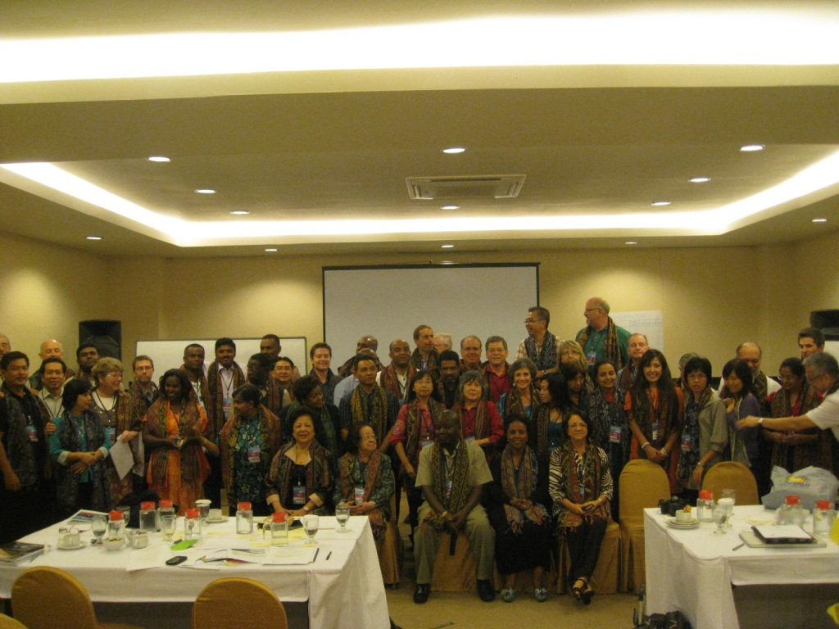
We believe that a call has already gone out from God to a group of His servants living in different parts of the world to stand up together against the rising tide of onslaught on the church of Jesus Christ through families. They are the ‘bravehearts’ God has been preparing over the years for taking such a stand.
Transform World Global Challenges Summit 2012
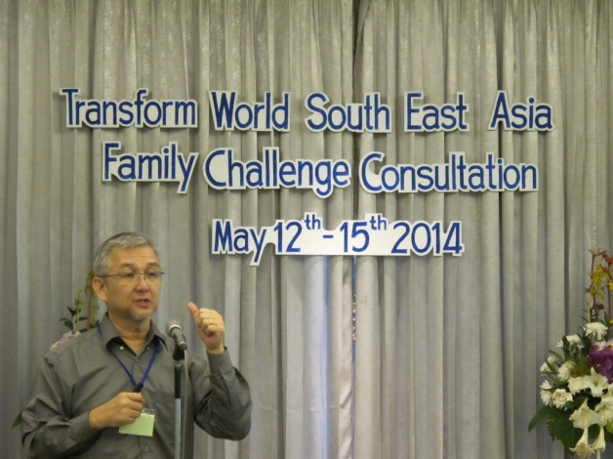
The first rally call to these servant leaders was at the Transform World Global Challenges Summit in 2012, where 64 family ministry leaders from 18 nations gathered under the Family Challenge. So far, 90 leaders from 30 nations have responded to form the ‘Committed Core’ to lead our Challenge internationally. We are in the process of recruiting more to form both regional teams (the regional leadership team for South East Asia is now in place) and national teams round the globe.
Our Global Advisory Team was also established in 2012.
Please refer to the attached ebooklet on Family Challenge for more information.
- Global Partnerships
We are also serving on the Family Track of the 4/14 Window movement.
In addition, we recently entered into a partnership with the World Evangelical Alliance (WEA) in developing the family ministry of their global network.
- Our Invitation
The task ahead for the Family Challenge is indeed immense. There are just no quick-fixes for the broken family cisterns.
Would you consider putting your hands to the plough with us, standing together with the rest of us in taking up this Challenge?
You may already know the part you could play effectively in the Family Challenge process outlined above. Or, this may become clearer to you as you learn more of what God calls our Challenge to do and seek Him for your part in it.
God’s richest blessings to you and your family!
I look forward to welcoming you as a part of this critical Challenge of the hour.

Serving The King,
Matthew Ling
Family Challenge Facilitator (International)

Email address: twfamilychallenge@gmail.com
Skype address: matthewling1

Many families cannot see beyond meeting the existing life demands to consider the benefits that come from changes that we might suggest.

