Week of Prayer 2026
11-18 of January

GOD'S FAITHFULNESS TO HIS PEOPLE.
Stop to start again.
Salmo 78

The year 2024 was marked by an important event for the global evangelical people: the 4th Congress of the Lausanne Movement for World Evangelism was held in Seoul, South Korea. The Lausanne congress always represents in the history of contemporary evangelical people a time to pause together to observe the state of the church and the mission of the world, and then to leave together in a more conscious way and with the resources that the Word of God and His Spirit renew us.

One of the special features of that congress was certainly the emphasis on collaboration. The theme is not new in the Lausanne declarations, nor is it new for the Evangelical Covenant, which was born, develops and realizes its vision precisely in the wake of the collaboration permitted by the unity God established in Christ for His children.

Therefore, we thought that a worthy fruit of Lausanne 4 and to confirm a commitment made before God and His people of continued collaboration for the growth of the gospel in our nation and throughout the world, was to make an effort of common reflection on the Word of God among the Italian delegates who participated in the event, producing this material for the International Week of Prayer 2026 of the Evangelical Alliance. We are grateful to God for everyone's participation in this initiative.

We have chosen Psalm 78 to meditate together with all of you, dear brothers and sisters, on God's faithfulness to his church in every age. Considering this divine faithfulness, it is necessary to ‘pause’ to remember, to seek repentance and to abound in thanksgiving. Without this salutary pause at the foot of God's throne, one cannot ‘start again’ as a gospel people. This is true both nationally and globally. Let us pray that this prayer material will once again be a tool in God's hands to strengthen our love for one another and collaboration for the advancement of the gospel and God's justice in the world.

Consiglio Esecutivo Federale
Alleanza Evangelica Italiana

This year's material of the International Week of Prayer was coordinated by the Executive Committee of the Italian Evangelical Alliance in cooperation with the Italian Committee of the Lausanne Movement.

Program of the week

Day 1 - Psalm 78:1- 4 REMEMBRANCE: not to hide what God has revealed
Day 2 - Psalm 78:5-11 REMEMBRANCE: let us remember to pass on and not be rebellious
Day 3 - Psalm 78:12-26 REMEMBRANCE: we remember the highs and the lows
Day 4 - Psalm 78:17-33 REPENTANCE: human rebellion in divine mercy
Day 5 - Psalm 78:34-37 REPENTANCE: Recognizing insincere repentance
Day 6 - Psalm 78:38-55 THANKFULNESS: God is pleased to use mercy
Day 7 - Psalm 78:56-64 THANKFULNESS: God who does not remove righteous judgment
Day 8 - Psalm 78:65-72 THANKFULNESS: the God of grace and justice is there

Recommendations for Hosting a WOP Prayer Meeting

Many local churches in Europe take this Week of Prayer as an opportunity to organise joint prayer meetings, which we would like to encourage. Here are a few suggestions to keep in mind when you plan:

1. Please make sure that ALL evangelical churches are invited and included in your prayer gatherings. Make an extra effort to also reach out to the migrant churches. Do you have Roma churches that you could invite? Including everyone will make your unity richer and more diverse.

2. Going to several locations will add to your experience, so don’t forget about the smaller towns and communities. Each place is different and adds colour to your unity.

3. How can you express the vast diversity in your country in a practical way? Being open to others, making room for different communities adds surprising perspectives to unity.

4. Is your event relevant and appealing to youth? We encourage you to allow youth to participate and even help you plan and prepare. Unity across generations is essential for the Church.

5. Be creative when planning your prayer meeting. Make sure it is relevant and appealing, and double check that prayer occupies the bulk of time.

6. We urge you to keep a gender balance. Have both men and women working together to create a program that will help express diversity.

7. Consider the future. Imagine seeing this event grow throughout the years. How can you create this year’s prayer event that will draw people back and bring their friends with them?

Day 1
REMEMBRANCE: not to hide what God has revealed
Psalm 78:1-4
It is not easy to listen. We all, in some way, find it difficult to stop and listen to others. Yet God invites us to make an effort in humility and give space for listening to his voice.
To lend an ear to God's voice means, for the believer, to silence the deafening din of his own thoughts, to reduce the noise of life's frenzies, to lower the volume of the various catechisms to which the world exposes him, and, above all else, to recognise his own need to live according to the words that proceed from the mouth of the Lord (De 8:3).
Verse 1 is clear in revealing to us that there is an intense connection between belonging and listening. God, in fact, claims his right to teach his people, who are called by him to listen to his Word and live according to its precepts. How much more important it is for the contemporary Church, grappling with the constant and bombarding emergence of ever new worldviews, to stop and listen to the gentle voice of her Lord.
God has acted in the past in favour of our predecessors, making himself known and showing his faithfulness. He has done the same with us, who have come to know him. Surely he will not fail to make himself known to new generations. His faithfulness will never fail.
God calls us to be active participants in his ambitious plan for salvation. Listening, in fact, preceeds action. So what answer will we give him?
Will we hide what the Lord has done? What use is memory if everyone keeps it to himself? Memory cannot be a mere recollection of things past; it must rather be a testimony of what God is, what He has done and what He will do.
At the Fourth Lausanne Congress in Seoul, it was stated several times that the Church must declare and show Christ together! Let us not forget that passing on the faith to new generations is part of the Great Commission. Faced with a generation at the mercy of an increasingly uncertain world, Jesus is the only answer, the strong tower in which to trust.
Let us turn down the volume of uncertainty that assails us on all sides and let us listen again to the voice of God, fearlessly raising up the banner of the Lord, so that his wonders may be contemplated and his praises proclaimed.
"We will not hide them from their children,
but tell to the coming generation
the glorious deeds of the LORD, and his might,
and the wonders that he has done."

PRAYER SUBJECTS
Thanksgiving
Lord, we lift you up and praise you. We wish to thank you for the great privilege of having made us your children and made us sharers in your great work.
Thank you that we can listen to you and obey you.
Our hearts are full of gratitude for what you have accomplished in history. We say thank you that you give us the joy of being able to taste your wonders and proclaim them to the next generation.

Confession
We repent because too often we have listened to the thousand catechisms that bombard us daily. We confess that we have not always shared the Gospel with the new generations.
Forgive us because we have often been lazy in passing on your Word.
We repent that we have judged the new generations.

Request
Father, help us to be faithful witnesses.
Grant us to proclaim your Word in all candour.
Help us to defend the faith.
Give us eyes of love towards the new generations.
Give us patience.
Lord, we are yours. We love you.

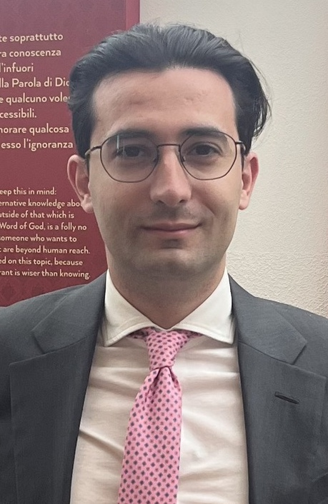

Giosuè Bua
Anti money laundering and counter terrorism financing Officer.
Deacon in an ADI Church in Milan.
Italian delegate Seoul 2024.

Day 2
REMEMBRANCE: let us remember to pass on and not be rebellious
Psalm 78:5-11

The Word of the Lord is a source of meditation and enlightenment for our days, but also, and above all, for the days to come so that the testimony of grace will remain for ever and be handed down, not only from father to son, but from generation to generation as we read in Psalm 78.

The Psalmist reminds us of the need for remembrance as a constant discipline in the life of God's people. It is not a natural attitude of the heart but a persistent training that deliberately opposes daily distraction and carelessness.

God commanded our fathers to make his works known to future generations. It is not a suggestion but a commandment, which we too often neglect and which, as a consequence, produces rebellion. Remembering helps us not to repeat the same mistakes of the fathers, remembering is like looking in the mirror to see whether we are obeying God or following in the rebellious footsteps of those who have gone before us.

This constant ‘remembering to pass on’ must be an integral part of our daily lives as believers. The heart of man is insanely wicked and for this reason needs a daily check-up in the light of God's Word.

The Psalm is also a warning to the people of God in its entirety. A people that remembers and remembers the works of its God and remembers the errors of the fathers is protected from unfortunate and painful downfalls due to its disregard for God's guidance. God does not change, his history reveals this, and when the church is disciplined in constant remembrance, one to another, of God's merciful grace in Christ, it is affirming its will to remain faithful as a people.

Will our sons and daughters, brothers and sisters looking back be able to say of us that we have kept the testimony, will they be able to pass on to others what God has done in our personal lives and in the lives of our churches?

PRAYER SUBJECTS

Thanksgiving
We praise you Father for who you are and for Jesus, the Word made flesh for us.
Lord Jesus we thank you for your Word that has come down to our day, we thank you for our fathers in the faith who fought for the truth.
We thank you for the freedom we have in you to proclaim your name and your works, even in the midst of persecution.

Confession
Lord we repent if we have neglected the remembrance of your works and the transmission of them to one another and to future generations.
Forgive us for all the missed opportunities to share the gospel.
Forgive us if we have put our own people, programmes and events at the centre and not Your Word and Your Person.

Request
Heavenly Father help us to be examples not only with our words but especially with our actions. We long to see
a generation surrendered at Your feet,
a generation submissive and obedient to Your Word,
a generation steadfast in your ways
A generation strong in you
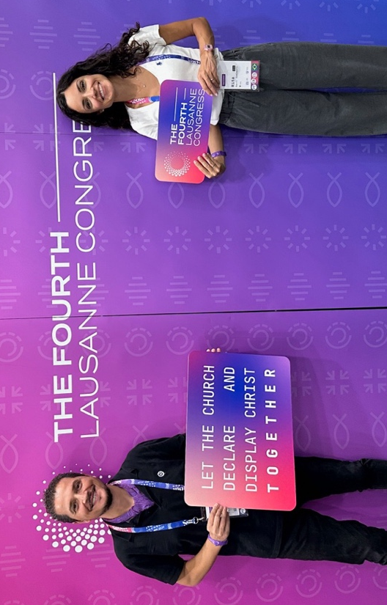
A faithful generation.

Paolo Codispoti
Orthoptist and optician
Pastor and church founder together with his wife Rita.
Member of the National Council of the Apostolic Church in Italy and Deputy Director of the Missionary Department. Italian Delegate Seoul 2024

Rita Codispoti
Trainer
Teacher Ministry Compass Italy
Italian Delegate Seoul 2024

Day 3
REMEMBRANCE: we remember the highs and the lows
Psalm 78:12-28

If you were to make a graph of your life so far, how would it look? A wiggly line of ups and downs? A histogram? Curves or lines? A pie slice? What does this line tell of God's faithfulness in your story? What if we were to do the same for the story of our churches and all God's people?

In Psalm 78, Asaph draws a timeline that reminds the people of the wonders of God, from the exit from Egypt to the exodus in the Sinai desert. He shows us a story of highs and lows.

- The highs reflect the extraordinary divine interventions - God who parted the sea, made his people pass through it, stopped the waters, guided them, split the rocks, quenched their thirst abundantly, made streams spring up, made waters flow like rivers.
- The basses, on the other hand, recount the rebellion and distrust of the people - they rebelled, they tempted God, they spoke against God, they complained, they did not believe in Him.

In a web of back-and-forth, a faithful, patient and provident God emerges. A God capable of bending the laws of physics to feed His people and never abandoning them, despite their shortcomings.

Looking at this Psalm, we cannot help but notice that these stories are not just a reminder of the past, but a reminder for us today. Just as the people of Israel saw God act in a powerful way, we too can recognize His interventions in our lives and in the life of the church. God has not forgotten His people and continues to invite us to converse and walk with Him.

Now, back to our charts. Let us take a moment to reflect: what are the highs for which we can praise God? And how can we respond with confidence in the low moments knowing that God is with us?

PRAYER SUBJECTS

Thanksgiving
Thank You, God the Father, for who You are, for not abandoning Your people to condemnation, but for unleashing Your wrath upon Jesus Christ so that we might believe in You and trust in Your salvation throughout our lives, through thick and thin.

Confession
In these times when it is easy to say that ‘the world is falling apart’, may we all together declare that it is often unconfessed sin within our communities that is destroying the church. I confess that I need Your help in my life. I confess that I am called to bring hope instead of despair. I confess that I have idols in my heart that keep me from trusting You.

Request
Lord, save us from ourselves! May we see You as a God who acts in our lives and in history. Keep our hearts from sinning and be our deepest satisfaction. Help us to daily remember Your works in our lives and not to fall into doubt or indifference.


Marychris Lajom
Photographer and graphic designer.
Deaconess of the Nuova Vita church (Bologna) organizer of youth camps.
Italian delegate and official photographer Seoul 2024

Day 4
REPENTANCE: human rebellion in divine mercy
Psalm 78:17-33

Psalm 78 gives us an overview of the history of the people of Israel and their continuous rebellion against God, despite the many manifestations of His mercy and providence. In verses 17-33, the psalmist highlights the ingratitude and hardness of heart of the Israelites, who, despite receiving tangible signs of divine care, continued to sin and doubt God's goodness.
Israel, despite witnessing extraordinary miracles directly, allowed themselves to be carried away by their own unbelief and dissatisfaction. Their demand for food in the wilderness was not a simple need, but an attitude of defiance and lack of trust in God's providence. In spite of this, the Lord showed his mercy by lavishing them with plenty of food, water in such abundance that the torrents overflowed, and raining down upon them meat, wheat, and manna. Where Israel's sin abounded, God's grace and mercy overflowed.

This obstinacy in sin is not just a thing of the past, but a reality that concerns us closely.

Often, we too, despite the blessings we have received, forget God's faithfulness and rebel against the guidance of the Most High. However, true repentance begins with the recognition of our rebellion. It is not just a feeling of guilt, but a concrete turning towards God, a change of mindset and life.

Although the Lord disciplined His people through trials and difficulties, He never abandoned them. This is a demonstration of His mercy: He corrects those He loves and invites them to repent for their sin. Repentance is not only sorrow for one's sin, but also the decision to distance oneself from it and to direct one's desires, choices, and life by relying on God's grace.
This is the restart offered by God: acknowledgement of one's rebellion and sincere repentance.
Today, as God's people, we are called to pause to remember God's faithfulness, acknowledge our mistakes and start again with a renewed heart.

PRAYER SUBJECTS

Thanksgiving
For God's faithfulness despite our sin.
For His mercy that provides for our needs despite our unbelief.
For the patience of the Lord, who does not treat us according to our sins, but according to His love.

Confession
For the times we have doubted God's faithfulness, challenging His sovereignty.
For our resistance in allowing ourselves to be led by Him and our stubbornness in following our own will.
For the selfishness that arises from an ungrateful heart.

Request
For a humble heart, ready to acknowledge its mistakes and return to God.
For a deeper understanding of God's will for our lives and his church, prompting us to live in faithfulness.
For the strength to start again with a renewed heart in His grace.



Damaris Marletta
Civil Aviation Authority Officer
Member of the Religious Freedom Commission
of the Italian Evangelical Alliance
Italian Delegate Seoul 2024



Chiara Lamberti
Journalist
Member of the Press Office of Ideaitalia, newsletter of the Italian Evangelical Alliance
Italian Delegate Seoul 2024

Day 5
REPENTANCE: Recognizing insincere repentance
Psalm 78:34-37

We have arrived at the heart of the psalm and right here in its centre is a strong admonition. There is a common saying that goes like this: ‘you understand the value of a person when you lose them’. This seems to be the snapshot of God's people in these verses. Having lost God's favor he realizes that without him he is nothing, without support or hope. So, she returns to her beloved full of sweet words, eager to find him again, or perhaps just his benefits? But this romantic feeling is short-lived because it fills the lips but not the heart, which remains distant and unfaithful.

It is a repentance no worthy of the name. God's people cannot help but admit that they depend on their Lord and Savior in all things but think they can separate their covenant blessings from their love for the covenant Lord. This attitude that characterized the people of Israel is always at the door of the church in every age.

When we see crises occurring due to our unfaithfulness, when God's righteous judgement meets us, what is the attitude of our heart? Are we ready as a church in our local contexts and globally to humble ourselves before God with a sincere heart, loving God's glory even before the benefits he bestows upon us?
The line is very thin, but God requires nothing more of us than that we love him with all our heart, with all our soul, and with all our mind (Matthew 22:37).

True repentance, the kind that can awaken hearts and reform the minds of entire generations, is not the kind that wets our cheeks during a prayer meeting and fills our mouths with adulation during our praise meetings, but it is the contrite and afflicted hearts of men and women of God who weep over the shattered walls of disobedience and the dry bones of perdition, and are willing by faith to remit their sins and weaknesses to God to be not only comforted by Him but also washed and cleansed to bring glory to Him. Sanctification however beneficial is a painful process of abandoning the old for the new, of suffering for the name of God, even persecution for His honor. Not exactly a romantic perspective.
But ‘Blessed are those who mourn, for they shall be comforted’ (Mt 5:4). There is no real consolation for a people who are not ready to repent sincerely.

PRAYER SUBJECTS

Thanksgiving
We thank you that your Word always tells us the truth and enables us to see even the darkest places in our souls.
We thank you because in Christ you have not stopped at our insincere repentance but have carried out your plan of salvation in spite of us.

Confession
We confess to you that throughout history we have been a rebellious people who ran to you more for the bread and security you offered us than for your heart and life you gave us.
We confess to you that this attitude still characterises us today. We ask your forgiveness because we often seek you only for peace and security but are unwilling to accept the suffering that love for you entails.

Request
Lord, fill us with Your Spirit to love You even when the prospects You place before us are not rosy.
Grant that we may see when we seek you only with our lips but not with our hearts so that our repentance may be sincere and bring true transformation.



Lucia Stelluti
Pedagogist
Vice President of the Italian Evangelical Alliance
Italian Delegate Seoul 2024

Day 6
THANKFULNESS: God is pleased to use mercy
Psalm 78:38-55

We all appreciate receiving a thank you for something we have said, a word of appreciation that acknowledges an undue effort on our part. Not only that, universally, in our various cultures, but the absence of thanks is also seen as rude, and the greater the favor received, the more serious the absence of thanks.
At the same time, it is almost unheard of to find a person who continues to do good to those who lack gratitude. Who is not only ready to go beyond what is due but is well willing to repeat this action despite indifference or contempt. “It's not normal,” we would think; perhaps even “It's not right.”
Well, then our God “is not normal,” “not right,” but holy and good. For so he acted toward Israel, and so he continues to act toward his people today. He remains faithful when we are unfaithful; He is patient and slow to anger when we deserve condemnation.
All this, however, for God is not doing violence to Himself; it is not a having to restrain, by a higher principle of self-control, the wrath He would like to pour out with pleasure and satisfaction upon us. All this stems from his nature as a merciful, merciful God, full of love toward his creature. Indeed, as Micah 7:18 states, this God of ours is special and unique. “What God is like you, who forgives iniquity and passes over the guilt of the rest of your inheritance? He does not hold his wrath forever, for he is pleased to use mercy.”

This mercy, however, comes at a price: for His righteous wrath was poured out at the cross on His Only Begotten Son, Jesus Christ, for our forgiveness.

Understanding this will not only lead us to thank God for His manifold blessings, it will lead us to want to remember the benefits we have received, to confess our rebellion, to repent for our shortcomings, and to worship Him for His nature is so wonderful! What God is like you, leading your people through a desert like a flock? Who remembers who we are, made of flesh, a breath that goes and does not return? Who takes pleasure in using mercy?

PRAYER SUBJECTS

Thanksgiving
Lord God, we want to pause to thank you for your mercy. We thank you that you do not punish us in proportion to our faults, that you do not hold your wrath forever. We thank you and praise you for your mercy, for your goodness. We praise you because you are a God who takes pleasure in using mercy.

Confession
Lord God, we confess our shortcomings in not being thankful as we should; in failing to honor your mercy, failing ourselves in showing mercy to others; in being quick to anger, and slow to forgiveness. We appeal to you, to your mercy, through the merits and sacrifice of the Lord Jesus.

Request
Lord God, grant us your compassions each morning, and help us to have a heart more and more like that of the Lord Jesus. Help us not to abuse your mercy, but to honor it with a life of gratitude and faithfulness, patience and goodness. Fill us with your Spirit and sustain us in being your people who represent you well in this world.

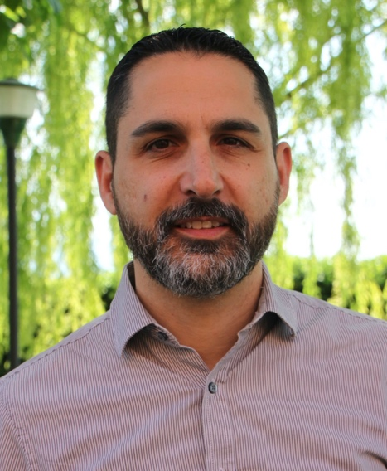

Daniele P. Pasquale
Dean and lecturer at the Istituto Biblico Evangelico Italiano (Rome)
Italian Delegate Seoul 2024

Day 7
THANKFULNESS: God who does not remove righteous judgment
Psalm 78,56-64

The Bible is realistic. It does not sweeten reality or even remove it. It presents it as it is, that is, as God sees and interprets it. In this section, the psalm recalls what happened after the settlement in the promised land. Instead of remaining faithful to their covenant commitments, the people tempt God, go astray, are disloyal and revolt (vv. 56-58). Even, God is provoked with abominable practices. Sadly, this is the description of the faithless response that often characterizes the church.

In analogy to the exodus in which God had delivered the people from slavery, God in Christ led us into the new exodus, that is, saved us by grace through faith alone. Now, as then, our response, instead of being characterized in the sign of faithfulness and service, is often manifested in arrogance, know-it-all and rebellion. Our unresolved lives, our restless churches, our ambiguous witness are nothing but modern versions of this section of the psalm.

What happens then? God does not remain insensitive to what happens. He is patient, but he is just. In his justice, he is “wroth,” and his wrath is not passive. God's judgment is manifested in the removal from the tabernacle (v. 60), in the enslavement and defeat of the people, even its youngest and strongest members (v. 63) and the “religious” ones (v. 64). Inside the covenant are commitments and responsibilities. Failure to meet them always has disastrous consequences.

Even in the new covenant established by Christ by grace through faith, responses to salvation received are expected. God the Father expects the gift of his Son in the power of the Spirit to raise regenerated lives that walk faithfully and healed, not perpetually unstable and contrite. For his sons and daughters, God's fatherhood is merciful but demanding: “the Lord corrects those whom he loves and punishes those whom he recognizes as sons” (Hebrews 12:6).

Certainly, in the new covenant Jesus Christ was the obedient Son who took upon Himself the Father's wrath against sin (Isaiah 53) and propitiated it (Romans 3:25). This has enormous consequences: those who are united with the Son know that God's righteous judgment has fallen on Him in our place but those who persist in being against Him must know that sooner or later that righteous judgment will be executed. As Jesus himself says; “Whoever believes in the Son has eternal life, but whoever refuses to believe in the Son will not see life, but the wrath of God remains on him” (John 3:36).

PRAYER SUBJECTS

Thanksgiving
Thank you, Lord, because salvation is not based on our performance (otherwise it would be uncertain and unstable), but on the completed and perfect work of Jesus Christ who gave His life for ours.

Confession
We acknowledge that our response to the salvation we have received (personal, family, church) does not live up to the gift received, but is often steeped in lukewarmness, shallowness and disobedience.

Request
We ask you, O Lord, by the power of the Holy Spirit, to stir in us a zeal for the commitments that flowed from our covenant with you so that our witness may be whole and generous so that it reflects the new life we have received in Jesus Christ. Protect us from the stubbornness of our hearts and the harshness of our behavior. Work in us so that all church members may not have lives bent in them but reoriented by the gospel.

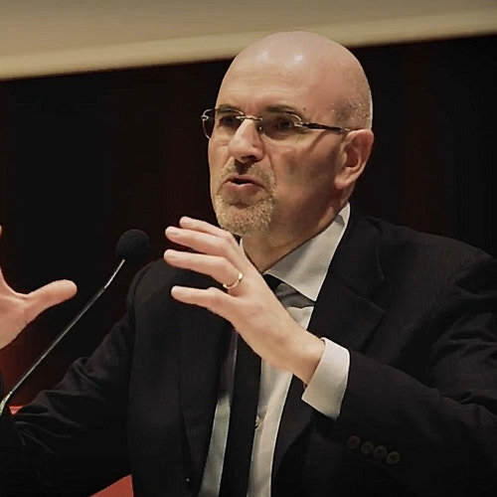

Leonardo De Chirico
Pastor of the Breccia church in Rome.
Director of the Reformanda Initiative.
Member of the Theological Commission of the Italian Evangelical Alliance.
Italian Delegate Seoul 2024

Day 8
THANKFULNESS: the God of grace and justice is there
Psalm 78:65-72

Clearly then, Psalm 78 traces God's presence and faithfulness in Israel's history. The song emphasizes the need for God's people to remember, to repent, and to be thankful.

Today, looking at the church in Europe it might seem that the situation is similar. Therefore, it is essential for us to recognize that we are fragile, remember the best story-that of His faithfulness-and return to rejoice and give thanks.

“Then the Lord awoke as from sleep” (v.65). It might also seem that God is far away when we see that people around us are indifferent to His truth, and that often our churches, just like God's people, are fragile and inconsistent. Yet, we give thanks that in spite of everything, God always remains near. And at the right time He awakens, to awaken.

God always intervenes in justice. Where we prefer our way to His way, He remains just by not good-naturedly overstepping our sin. This is precisely why God works in any way He wills to highlight that His sovereignty takes center stage even in our reprehension. Even his abandonment is realized through the work of enemies (v.62). Yet where enemies oppose his people and his will, God remains just, intervenes and triumphs over them (v.66).
While struggling in our contexts to promote justice at every level, we are reassured that the final scene remains God's: the righteous judge, displaying his triumphant justice over all and sundry.
So we thank him.

God always shows his stupendous grace. Instead, the weak and failing people, deserving only of judgment, find themselves before a God who does not give up, who remains faithful to who he is. The God who justly punishes, but a God who is merciful and generous. Judgment is joined by grace.

God, by grace, chooses the tribe of Judah, chooses Mount Zion and does so out of love (v.68). He shows grace in maintaining his faithfulness. Generously, in the midst of the people he builds his temple remembering the wonder of his presence (v.69) but supremely (v.70-72) he arouses David, the king after his own heart. He arouses him from the humility of the fold (v.71), he calls him to shepherd his people (v.71) and they do so with a heart of integrity and a wise hand (v.72).

We too, God's contemporary people, are lacking and in need; we too enjoy God's favor, which guarantees his powerful presence in our midst to guide us. We see his grace evident in having raised up for us one greater than David, the Great Shepherd who came, led us and gave himself for us. Yes, David led with an upright heart and a wise hand, but Jesus promises to be with us and to give us His Spirit to guide us and care for us. And the Great Shepherd is the One who gave Himself for us, His people.

Despite our limitations and weakness, what a magnificent assurance that the Lord remains faithful, that He does not treat us according to our merits, but that His grace abounds upon us. In the midst of the challenges of our contemporary contexts, secular and ecclesial, it is God's presence and action that makes all the difference. So we thank him.

PRAYER SUBJECTS

Thanksgiving
Thank you, Lord for always remaining with us despite our frailty
Thank you because you raised up 'One greater than David' to shepherd, care for and lead your church.

Confession
We confess our frailty and our constant need for you
We confess that we often tend to forget that You are victorious and powerful

Request
Lord, manifest your righteousness during our personal, family, church, work, and political contexts.
Lord, make us thankful that You lead us and care for us personally and for Your people all.

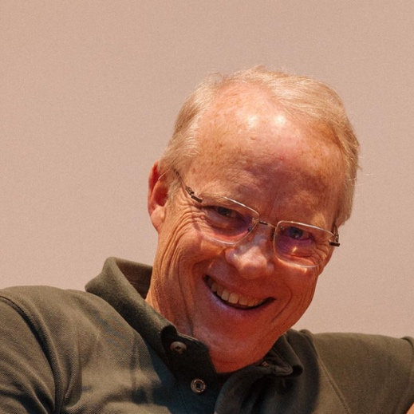

Jonathan Gilmore
Pastor of LifeHope Church (Palermo, Italy)
National coordinator of the Lausanne Movement in Italy
Italian Delegate Seoul 2024

